

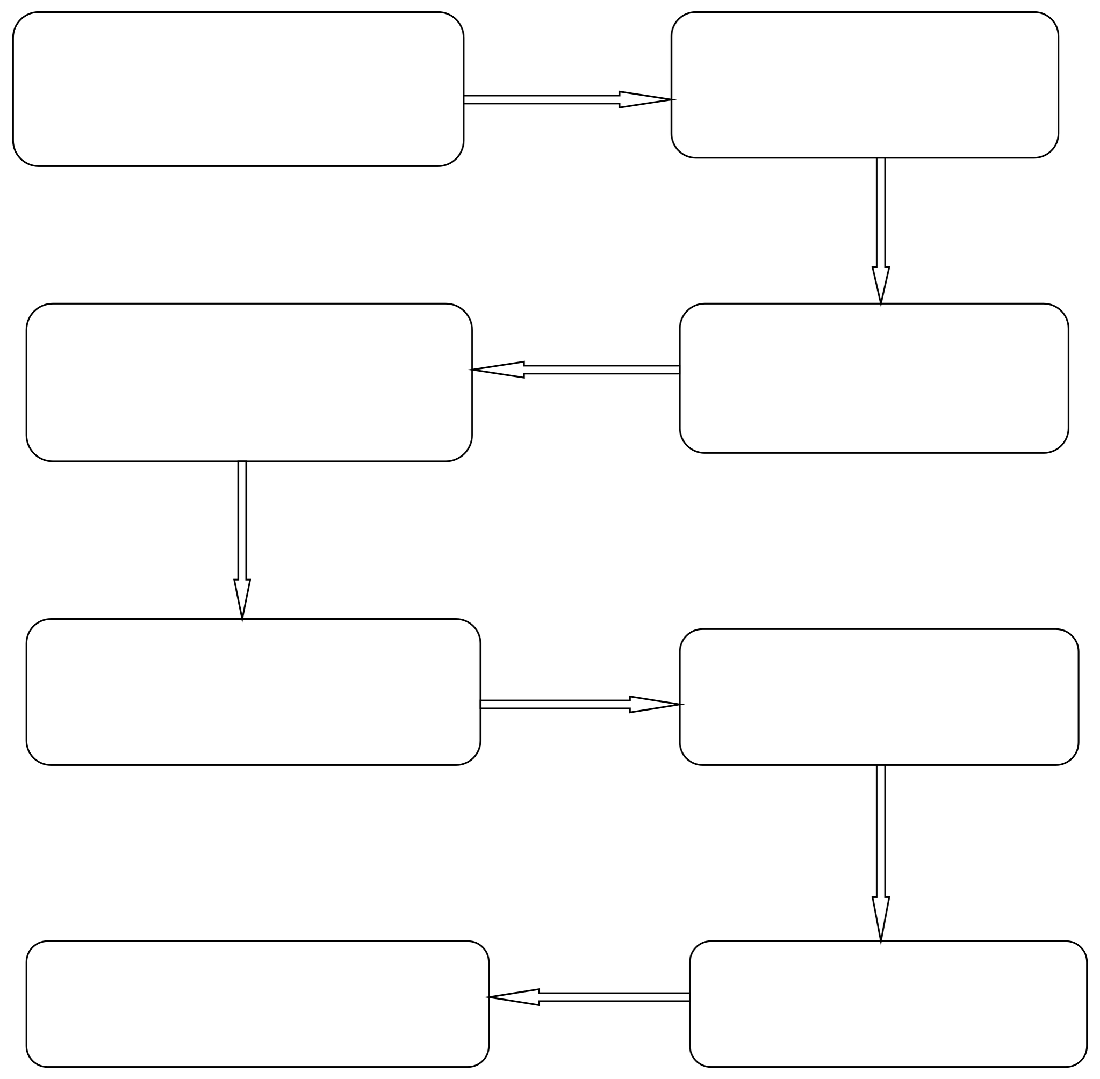

Inclusion of the arbitration agreement by the parties to the contract

A dispute arises between the parties

Defendant's response to the claim

Submitting a Claim to Arbitration

First, the election of a referee Arbitration Register

Conducting the arbitration session

Enforcement of arbitral award

Arbitrary decision- making

STAGES OF THE ARBITRATION CASE